Shaker Installation for Judge Dredd

This guide shows how to install the optional shaker supported by JD2-SkeletonGame.

The original Judge Dredd pinball machine did not come with a shaker. Installing this mod will not do anything if you run the original software.

List of Parts

[Shaker Motor Kit (Rev B) for Most Stern SAM System Games](https://www.pinballlife.com/shaker-motor-kit-rev-b-for-most-stern-sam-system-games.html) (502-5027-00-01 or 502-5027-00 Rev B)

[A-19720 Shaker High Current Driver Board](https://www.siegecraft.us/presta/index.php?id_product=80&controller=product&id_lang=1)

9 feet of red 18 AWG wire

10 feet of black 18 AWG wire

7 feet of brown 18 AWG wire (included in Shaker Motor Kit)

4 wood screws (1 inch)

1 four pin IDC connector

1 five pin IDC connector (included in the Shaker Motor Kit)

1 six pin IDC connector (can use the seven pin IDC connector included in the Shaker Motor Kit)

[2 cable clamps 1/4"](https://www.pinballlife.com/cable-clamp-14-diameter.html)

10 tie wraps (4 included in the Shaker Motor Kit)

2 #8-32 X 3/8" screws for the cover (included in the Shaker Motor Kit)

4 #8-32 X 3/4" screws (included in the Shaker Motor Kit)

4 #8-32 T-nuts (included in the Shaker Motor Kit)

Theory of Operation

This mod replicates the shaker circuit from Road Show. Judge Dredd has two free low power coil drivers (Solenoid 12 and 14). When Solenoid 12 is energized, this completes the circuit in the Shaker High Current Driver Board sending 20V DC through the shaker.

The Shaker Motor PC Board that comes with the Shaker Motor Kit is unused. Keep it for use in a Data East or a Stern machine.

Hardware Installation

No soldering required. An IDC insertion tool is recommended but not required. See the picture of the completed installation at the end of this document.

1. Pull out all wires from the five pin IDC connector included in the Shaker Motor Kit.
2. Pull out all wires from the seven pin IDC connector included in the Shaker Motor Kit.
3. Cut out the one wire connector keeping the red wire as long as possible
4. Cut out the other one wire connector keeping the brown wire as long as possible
5. Cut the seven pin IDC connector to form a six pin IDC connector. Choose the side to cut to retain 2 pins on one side of the key and 3 pins on the other side of the key.
6. Connect the blue and red wires to the five pin IDC connector as shown in the diagram below. The blue wire forms a loop connecting pin 1 and 2. The red wire forms a loop connecting pin 3 and 5.
7. Connect the black, brown and red wires to the six pin IDC connector as shown in the diagram below. The black wire forms a loop connecting pin 1 and 2. The brown wire connects to pin 4. The red wire forms a loop connecting pins 5 and 6.
8. Move the slam switch located the right of the tilt bob to as close to the front left corner as possible.
9. Temporarily screw the cover on the shaker motor. Choose a location for the shaker assembly close to the front left corner. There should be enough room for the cover without touching the tilt bob or the coin box. The long side of the cover should be in the same direction as the long side of the cabinet. Unfortunately, you cannot use the template in the Shaker Motor Kit because of the different parts on the left side of the cabinet compared to a Stern.
10. Remove the cover. Mark the 4 screw locations with a pencil. Drill through the cabinet bottom with a 7/32” drill bit.
11. Hammer the T-nuts in the holes underneath the cabinet.
12. Screw the shaker motor.
13. Screw the cover
14. Connect the five pin IDC connector to the Shaker High Current Driver Board. Choose a position for the Shaker High Current Driver Board on the cabinet bottom respecting the length of the wires. The best place is on the other side of the divider plank. For consistency with other Williams machines, it is best to position the board with the five pin IDC connector on the left and the six pin IDC connector on the right.
15. Screw the High Current Driver Board using the 4 one inch wood screws.
16. Connect the six pin IDC connector to the High Current Driver Board.
17. Run the wires to the left side of the cabinet and through the tube to the back box. Pick the tube that contains cabinet wires. The other tube contains playfield wires. Use tie warps to keep things tidy.
18. Connect the brown wire to pin 5 of connector J127.
19. Run the black wire to the left, up and then right of the WPC Power Driver board to reach connector J103.
20. Connect the black wire to a four pin IDC connector making a loop to connect two pins (all pins on J103 are grounded).
21. Connect the four pin IDC connector to J103
22. Run the red wire to the left, up and then right of the WPC Power Driver board to reach connector J107.
23. Connect the red wire to pin 5 of connector J107.
24. Use tie wraps to keep the red and black wires tidy.
25. Use a 1/4" wire clamp to hold the red and blue wires near the High Current Driver Board.
26. Use a 1/4" wire clamp to hold the black, brown and red wires near the High Current Driver Board.

Connection Diagrams

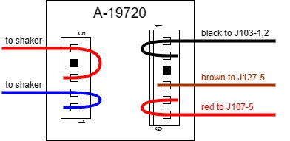

Judge Dredd Backbox:

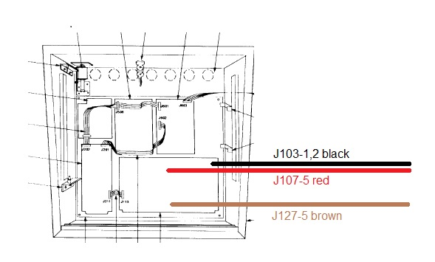

Software Installation

Start JD2-SkeletonGame. Go in the service menu, choose Settings, choose Machine Settings, find the Shaker setting and enable it. This only needs to be done once.

Completed Installation

